Jerry Olds  
1001533643  
IE-4378-001  
10/29/2019

Path Planning needed for Competition

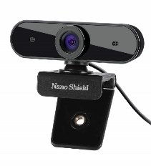

N910 Skype Web Camera Wide Angle  
 (Used for lane detection)

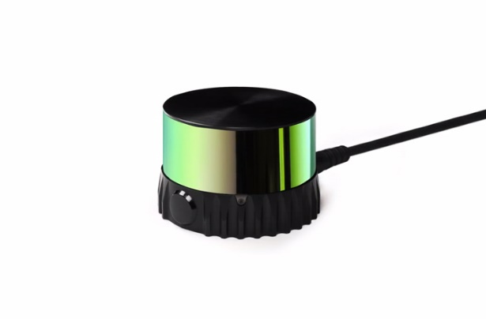

Ouster OS-1 Performance Lidar Sensor  
 (Used for obstacle detection)



Robot Operating System package BreezySlam for map building and path generation



OpenCV to detect lanes